Data Structure and Algorithm (DSA)

Swift Ex Logistics

Submitted by:
Warda Waris 2024-CS-720
Ayesha Latif 2024-CS-726
Ayesha Liaqat 2024-CS-701
Umar Habib 2024-CS-729
Submitted to:
Sir Ali Raza
Dated: 31st Dec, 2025

Department of Computer Science

University of Engineering and Technology Lahore, New Campus.

Table of Contents
Data Structure and Algorithm (DSA) 1
1. Introduction: 2
2. Objectives: 2
3. Module Specifications: 2
3.1 Intelligent Parcel Sorting Module: 2
3.2 Parcel Routing Module: 2
3.3 Parcel Tracking System: 3
3.4 Courier Operations Engine: 3
4. Data Structure Justification & Comparative Analysis 3
4.1 Search & Registry: Hash Table vs. Others 3
4.2 Prioritization: Max-Heap vs. Others 3
4.3 Movement & History: DLL vs. Others 4
5. Time Complexity: 4
6. Class Diagram: 5
6
7. Flow Chart Diagram: 6
7
8. Conclusion: 7

Table of Figures
Figure 1 flowchart diagram 6
Figure 2: class diagram 7

1. Introduction:
The Swift Ex Logistics Engine is an autonomous simulation platform designed to model the complexities of a modern courier and supply chain network. The engine manages the end-to-end lifecycle of parcels, from registration and prioritized warehousing to dynamic routing and delivery. A core requirement of this project was the development of a "Smart Engine" using custom-built data structures, entirely independent of the Standard Template Library (STL), to ensure maximum control over memory management and computational efficiency.

2. Objectives:
The primary objective of the Swift Ex project was to develop a fully autonomous engine that manages the end-to-end lifecycle of parcels while maintaining high efficiency and data persistence without the use of the Standard Template Library (STL). By architecting the system with custom data structures, the project aimed to achieve superior manual memory management and implement highly specialized logic capable of making real-time decisions, such as identifying the most urgent parcel in a massive inventory, calculating the cheapest path across a dynamic city graph, and providing a forensic audit trail for every entity to ensure total operational transparency.

3. Module Specifications:

3.1 Intelligent Parcel Sorting Module:
This module acts as the organizational core. It utilizes a Max-Heap to manage warehouse sorting, ensuring dispatching is driven by importance rather than just arrival time.
- Multi-Key Comparison: Priority is calculated based on Delivery Tier (Overnight, 2-Day, Normal), followed by Weight, and finally arrival time (last_tick).
- Starvation Prevention: By including arrival time as a tie-breaker, the system ensures that lower-priority items are eventually processed once higher-priority items are cleared.

3.2 Parcel Routing Module:
The logistics environment or Map is represented as a Weighted Adjacency List Graph.
- Navigation: The engine employs Dijkstra’s Algorithm to compute the mathematically shortest and optimized delivery route.
- Reactive Logic: The system supports "Dynamic Edge Costs." If a road is blocked or congested, weights are adjusted mid-simulation, forcing the engine to generate a detour from the rider's current coordinates which makes system efficient by fulfilling this module.

3.3 Parcel Tracking System:
Tracking is managed as a forensic analysis trail within each parcel.
- Mechanism: State transitions (e.g., "SORTED," "DEPARTED") are recorded as ActionLog nodes.
- Storage: These nodes are stored in a Doubly Linked List (DLL), providing a fully chronological view of a package's journey throughout all stages of it being registered for shipment to being delivered.

3.4 Courier Operations Engine:
The physical workflow reflects a high-maintenance logistics hub through a three-stage structure: Pickup Queue, Warehouse Heap, and Transit Queue. A Global Stack records administrative changes, allowing operators to "Undo" actions and revert entities to their exact previous state. So, no parcel is delivered to right receiver at the right destination using optimized and best route available. May perform detour if something out of order happens during simulation.

4. Data Structure Justification & Comparative Analysis

4.1 Search & Registry: Hash Table vs. Others
- Selection: Hash Table (O (1) Average Search) using the DJB2 algorithm.
- Vs. Linear Search: A linear search takes O (N) time. In a high-volume system, a Hash Table allows for instantaneous retrieval regardless of dataset size.
- Vs. BST: A BST offers O (log N) search. A Hash Table’s O (1) lookup is superior for registries where total sorted order is not required, avoiding the rebalancing overhead of AVL trees.

4.2 Prioritization: Max-Heap vs. Others
- Selection: Max-Heap (O (1) Peek).
- Vs. BST: A warehouse sorting needs the most urgent items first then normal items. A Heap provides the "best" element faster and with simpler logic than a fully sorted BST.
- Vs. Sorted Linked List: A Sorted List requires O (N) for insertions. A Max-Heap performs insertions in O (log N), ensuring the system remains responsive during arrival bursts.

4.3 Movement & History: DLL vs. Others
- Selection: Doubly Linked List (DLL) (O (1) Removal).
- Vs. Queue: If a parcel in a rider's list of parcels and is delivered out of order, a Queue cannot remove it without dumping all other items. A DLL allows for O (1) removal from any position.
- Vs. Stack: While Stacks are ideal for LIFO "Undo" features, they lack chronological traversal. A DLL supports both forward tracking and backward reversal. That’s it’s the best to be selected.

5. Time Complexity:
Data Structure | Function | Time Complexity | Explaination
Hash Table | Insert / Search | O(1) | Direct index calculation via DJB2 hashing.
Hash Table | Resize | O(N) | Operation to maintain load factor.
Max/Min Heap | Insert / Extract | O(logN) | Logarithmic restructuring.
DLL (List) | Insert (Tail) | O(1) | Direct access via tail pointer.
DLL (List) | Remove (Node) | O(1) | Pointers updated without shifting elements.
DLL (List) | Get At (Index) | O(N) | Requires sequential traversal from the head.
Graph | Add Road | O(1) | Direct insertion into Adjacency List.
Graph | Shortest Path | O(E logV) | Dijkstra's Algorithm optimized with a Priority Queue.
Stack / Queue | Push / Pop | O(1) | Standard pointer or circular index updates.
Table 1: time complexity

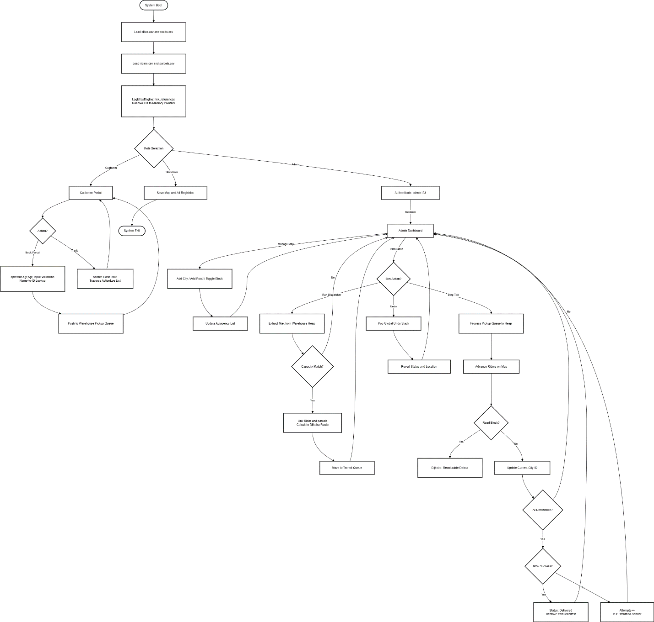
7. Flow Chart Diagram:
Figure 1 flowchart diagram

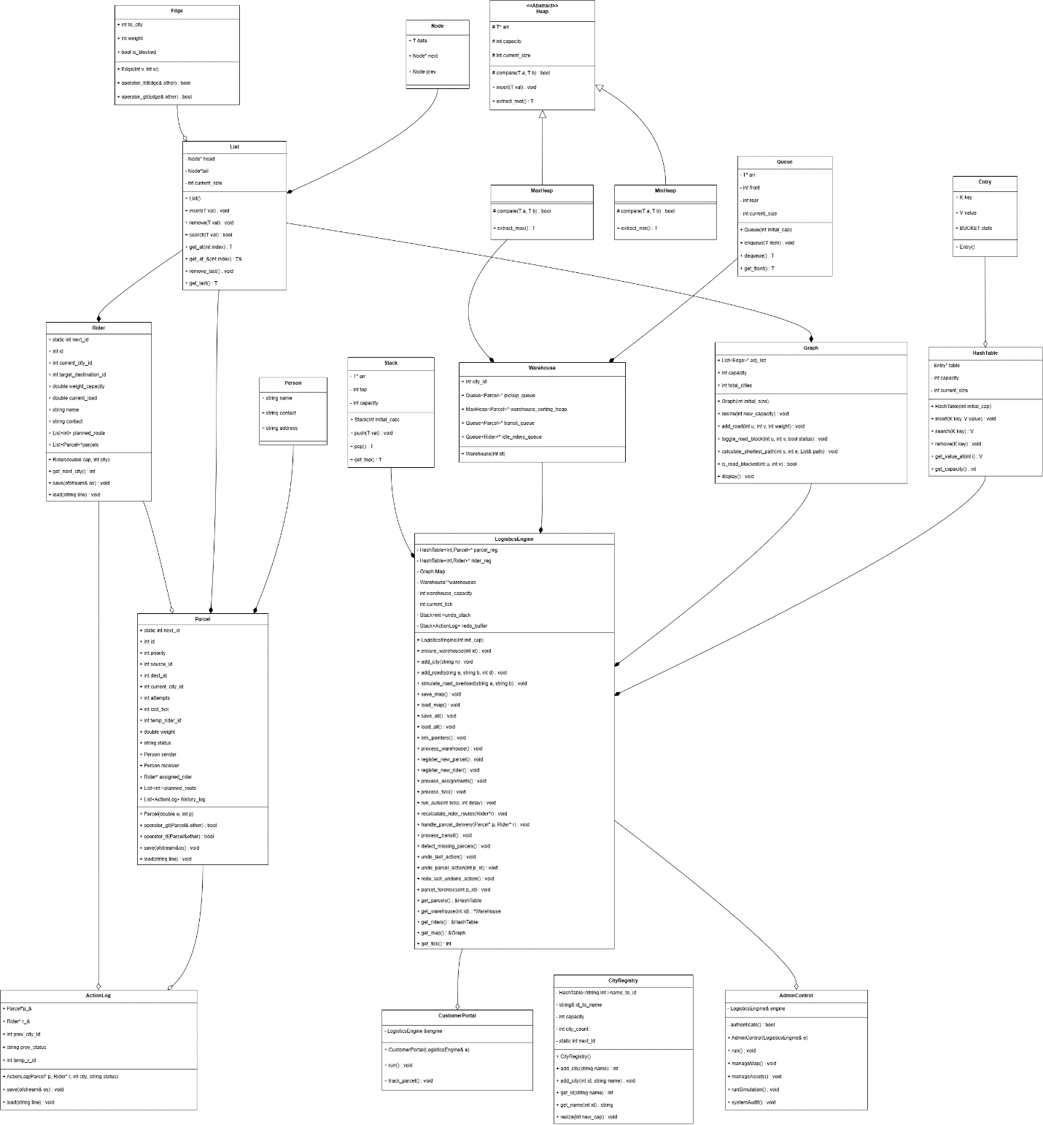
6. Class Diagram:
Figure 2: class diagram

8. Conclusion:
The Swift Ex Logistic Engine is a successful mix of smart data structures and real-world delivery logic. By using Hash Tables for speed, heaps for urgency, and Graphs for navigation, the team has built a system that is both fast and reliable.
The project moved beyond simple data storage to create an engine that manages a complex road network while keeping a detailed history of every package. This approach ensures that the engine is not just a database, but a reactive system capable of making high-speed decisions in a changing environment.

